R&R Portal

Log-in:

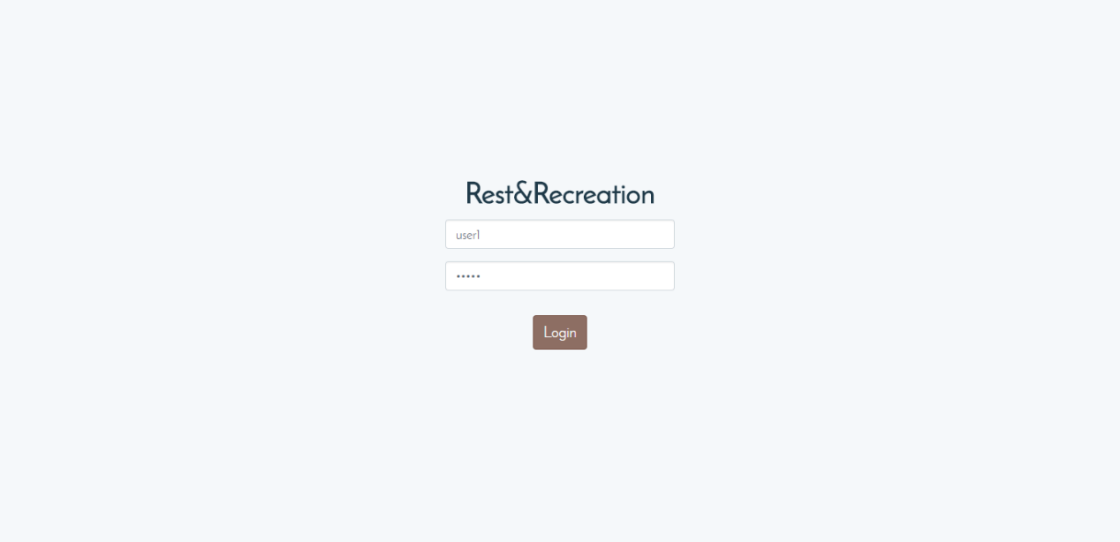

Going to the index or main page of the portal will lead you to the log-in page. The log-in details, the user-name and password, are provided by the Administrator.

Home:

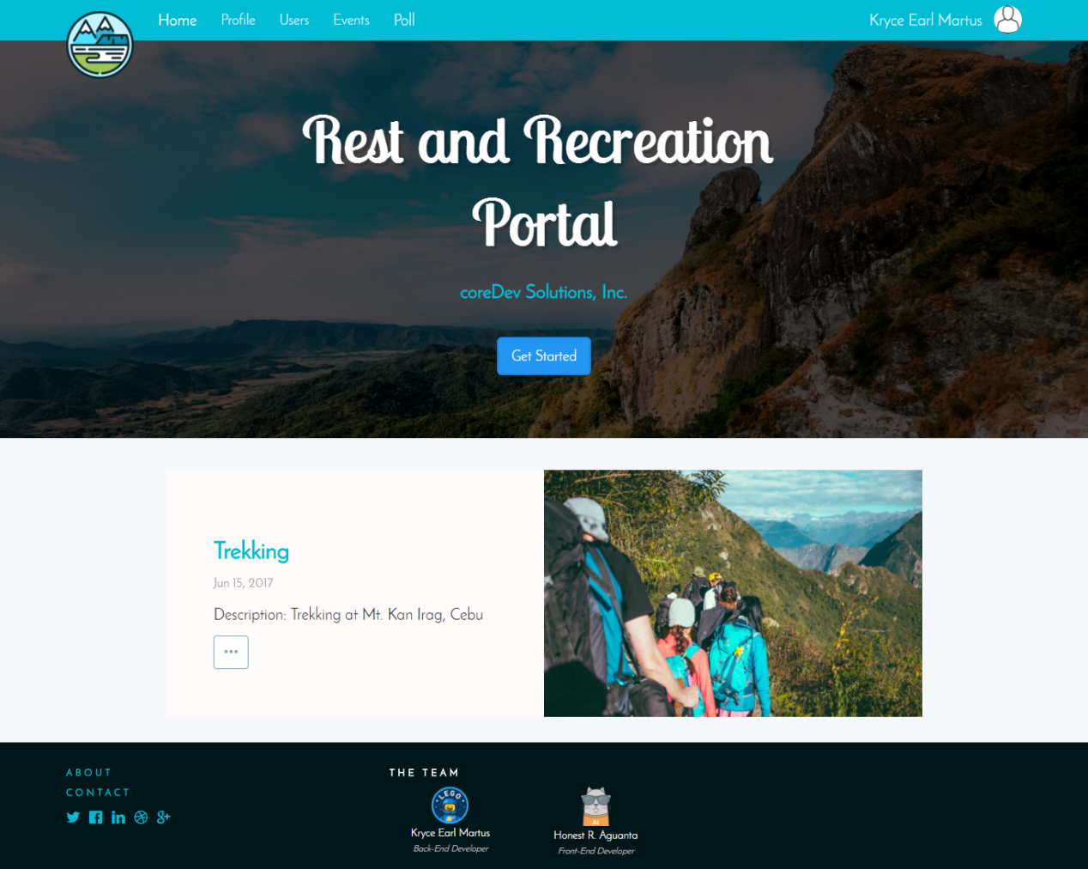After logging in, the user is redirected at the home page or the time-line of the portal. In this page approved events for the current and previous R&R are displayed.

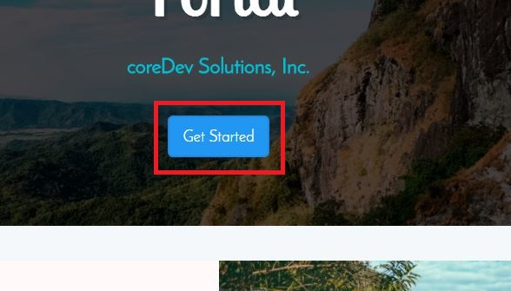

Through the “Get Started” button in the Home page, an administrator can start an ‘Event Voting Period’ for this month. 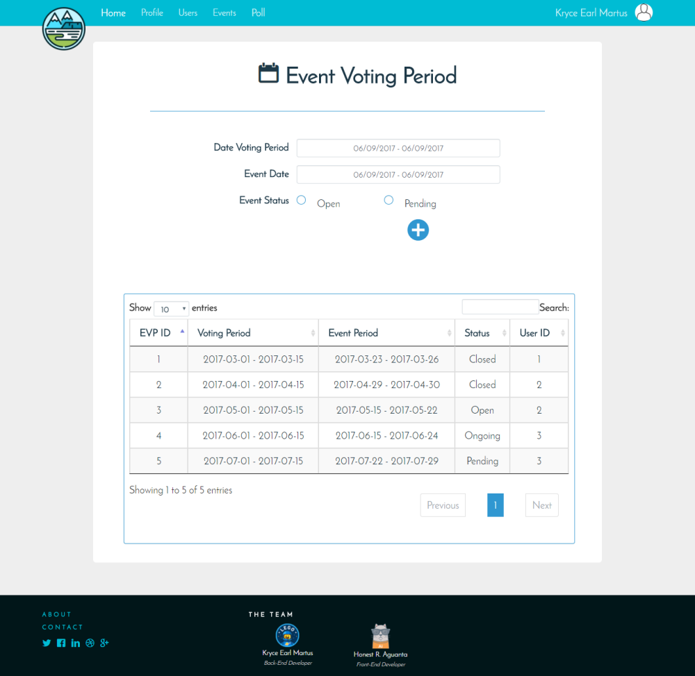

**Event Voting Period:**

The Event Voting Page is where an administrator can open an voting period and set the event date.

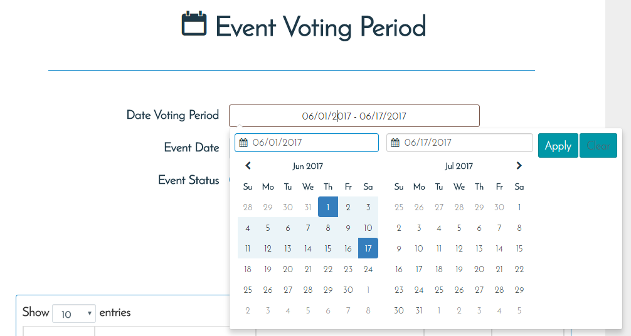

Once an Event Period and the event date is submitted, the EVP (Event Voting Period) will be shown in the data table below the form.

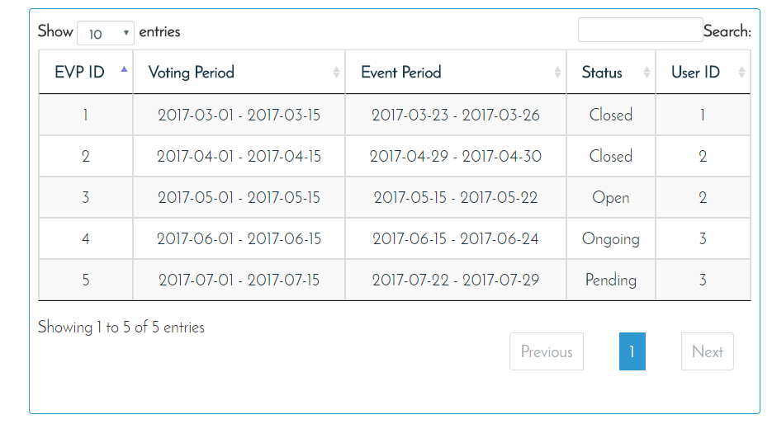

Events:

Once an Event Voting Period has been made and the local time is within the voting period, an administrator can then properly manage events.

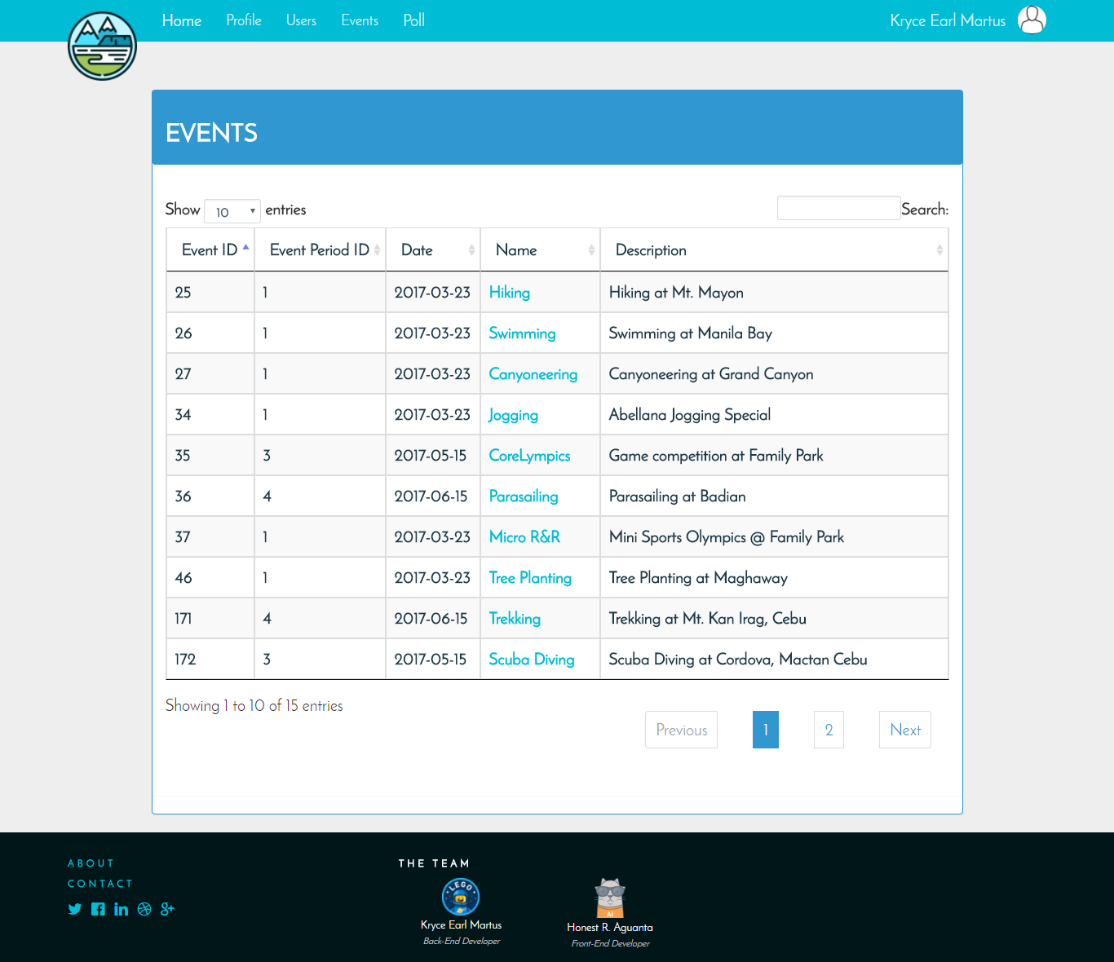

To add an event, select “Create Event” under the “Events” option in the navigation bar.

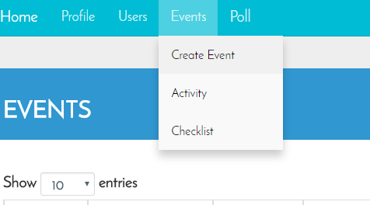

It will then redirect to the Create Event Page. Where an administrator can fill-up the details of an event and add it to the current Event Voting Period. This event will one of the choices to be voted upon in the EVP.

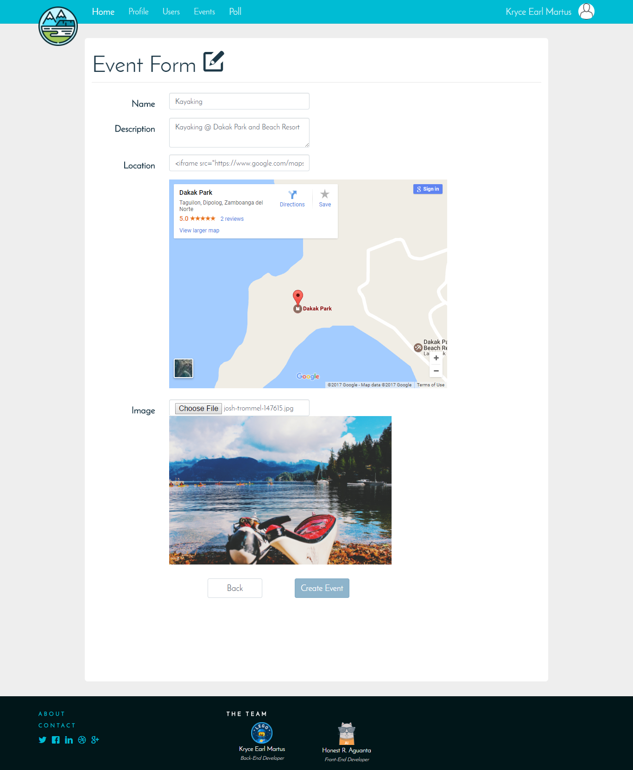

Note: To add an location, go to <https://www.google.com.ph/maps> and navigate the exact location where the event will be held.

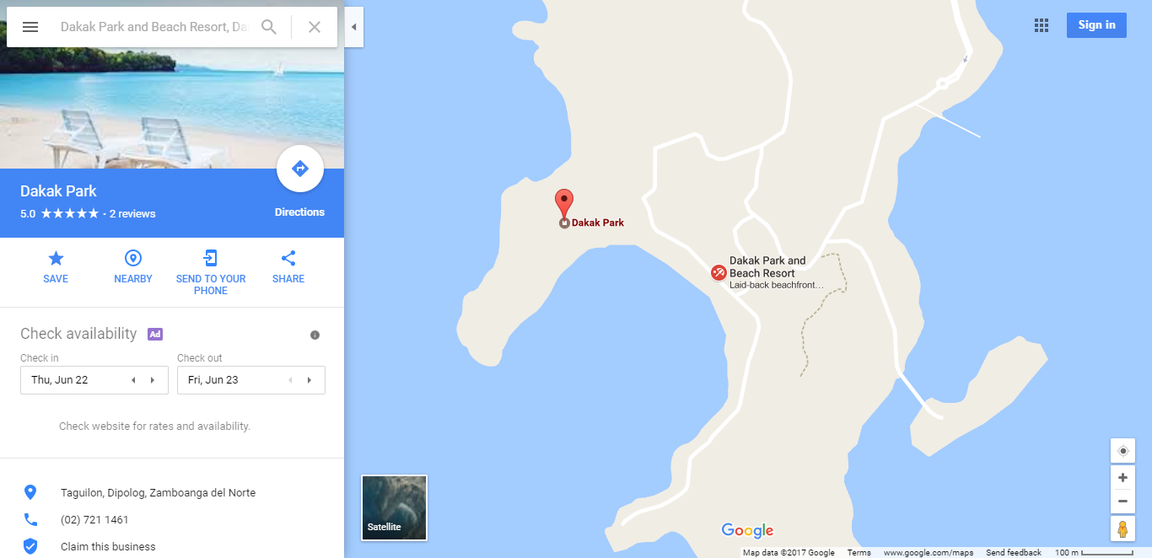

Click the menu, and select “Share or embed map”.

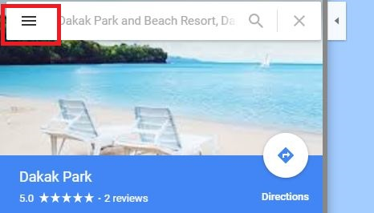

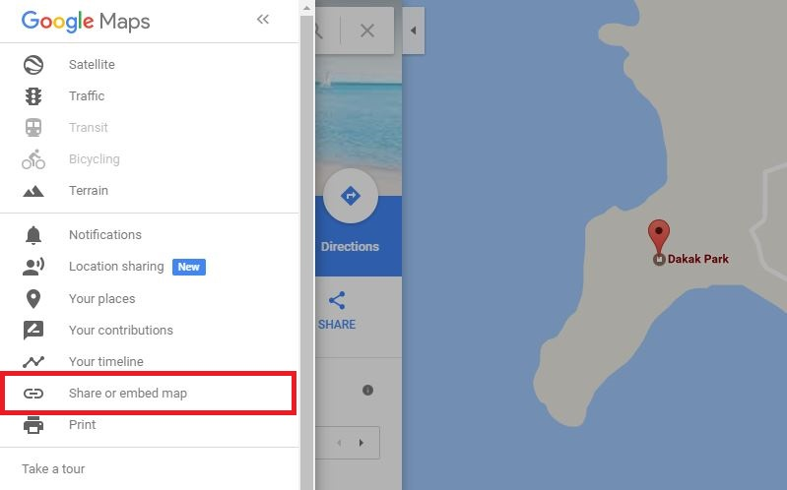

Choose the “Embed map” and select the Medium size. This must be in medium size to be compatible with the portal’s pages.

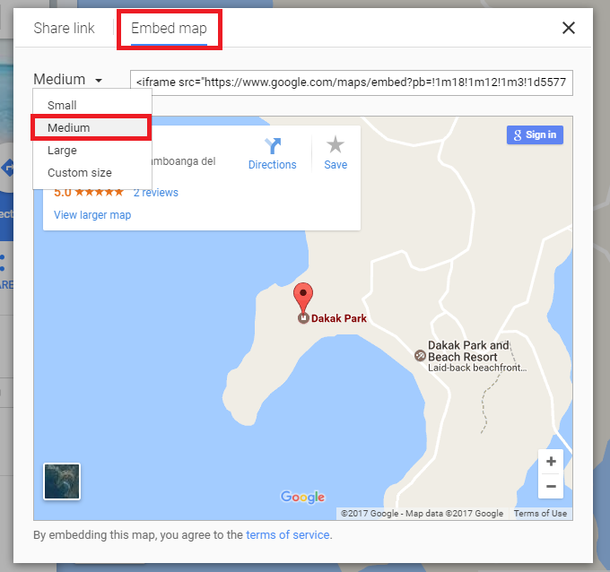

Copy the iframe tag and paste it in the location text area.

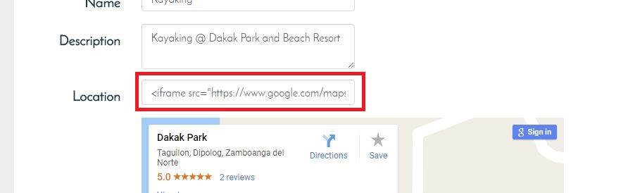

After submitting the Event Form, an administrator is then suggested to add Activities on the newly submitted event. By clicking the link in the message box, it will redirect to the Activities Page, either way the adding of events can be done later.

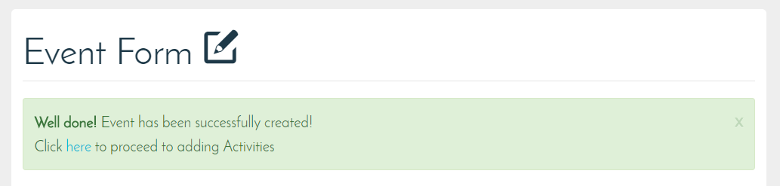

**Activities and Check list:**

Activities and Check list can be added through the Activity and Check list pages under the “Events” option in the navigation bar.

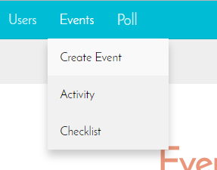 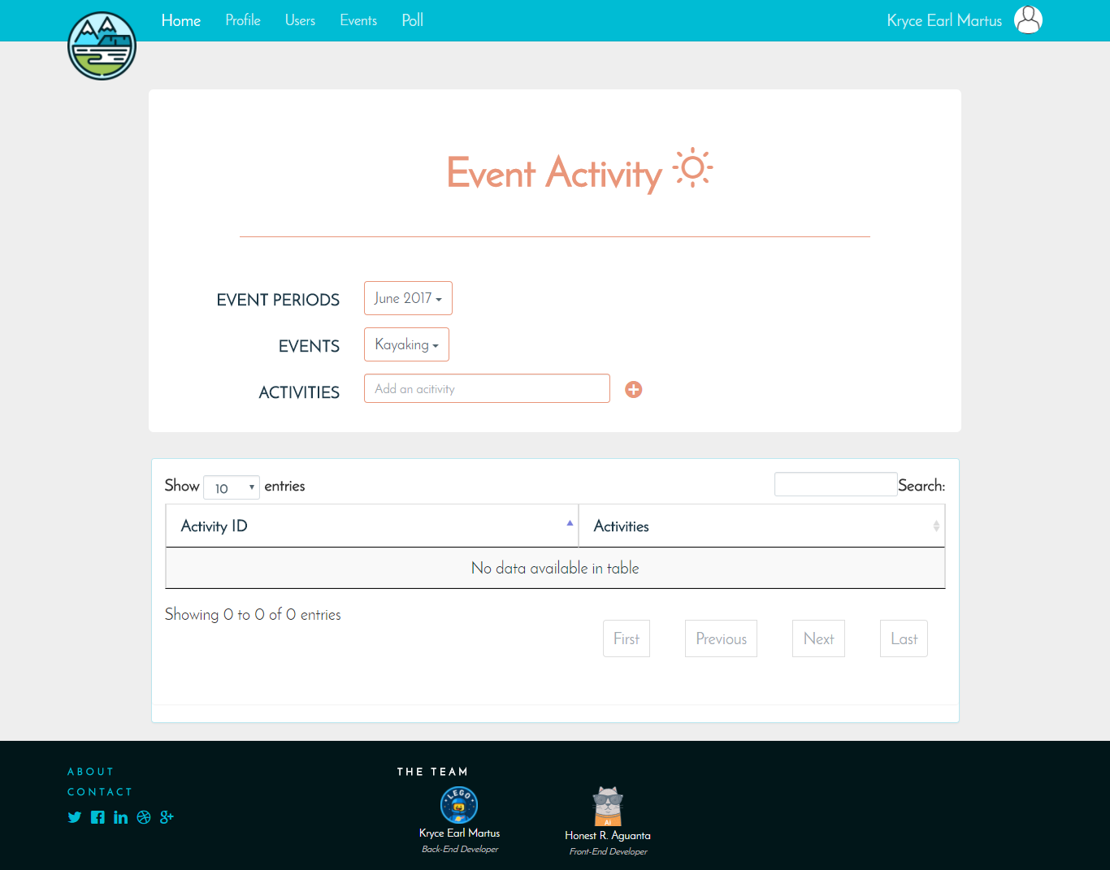

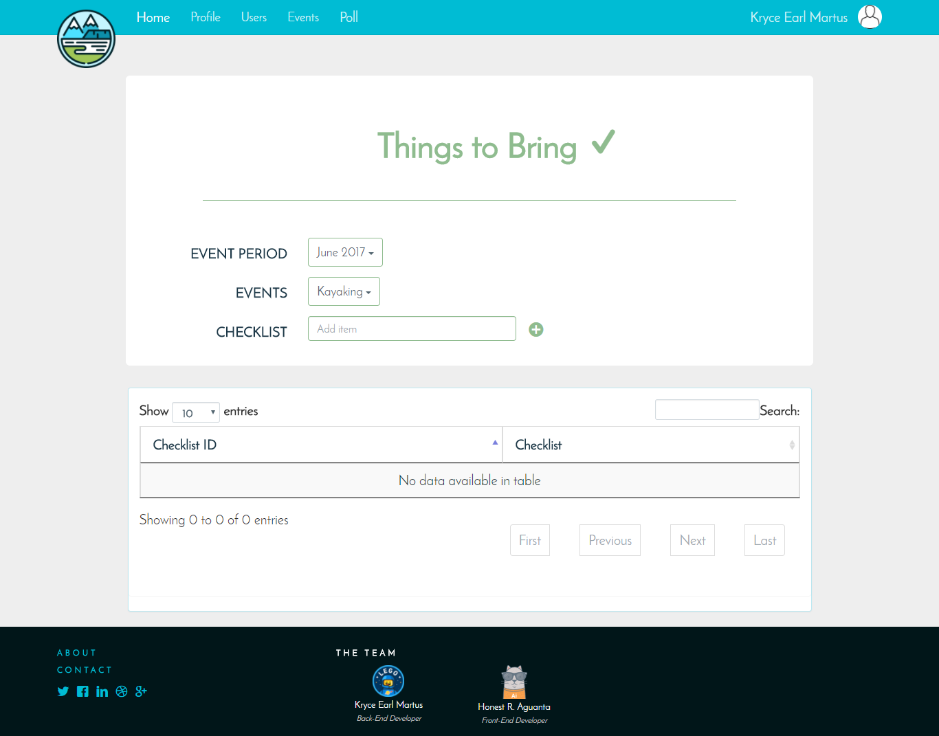

Technically, the Activity and Check list (Things to Bring) pages has the same layout and method on how to add an activity or an item to bring respectively. Find the event by selecting what event period it was registered. And then add an activity (if it’s Activities) or item (if it’s Check List). It will then be displayed in the data table below the form.

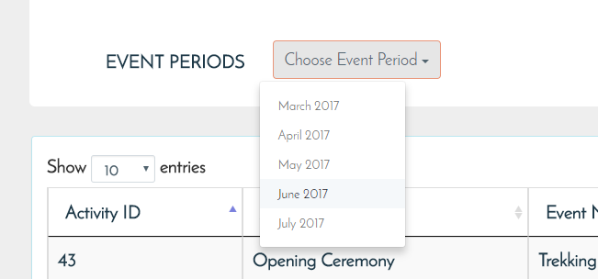

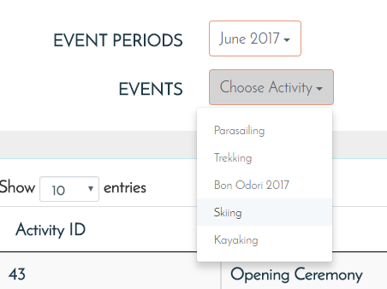

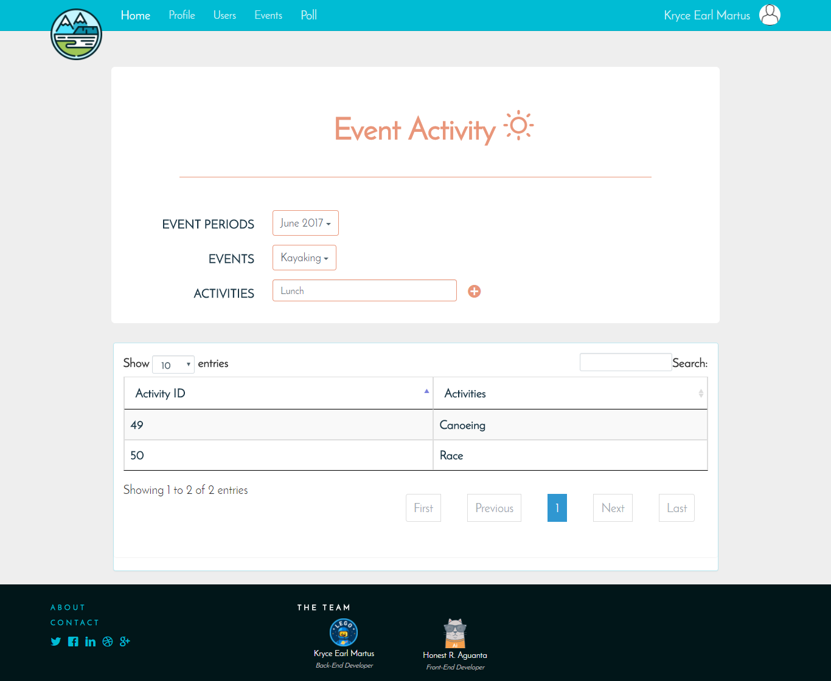

**Users:**

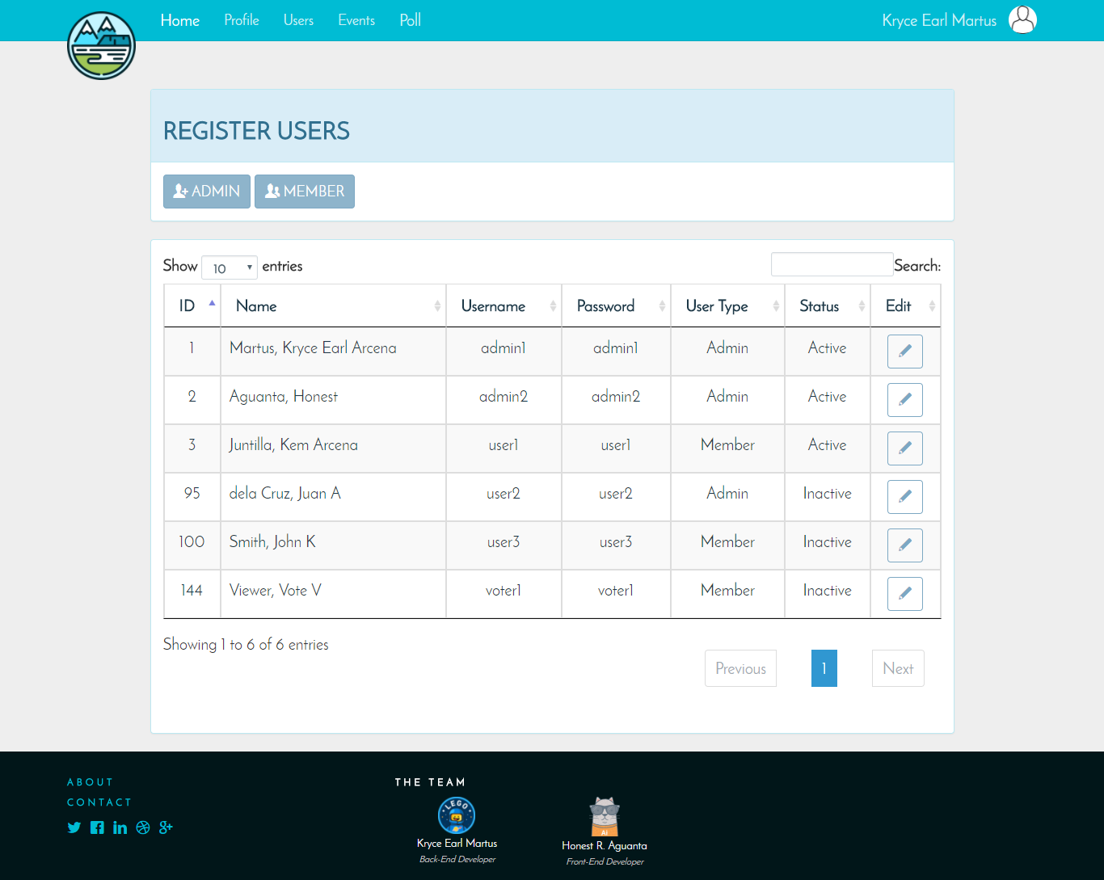

As said in the Log-in portion, for a user to have an access to the portal, an administrator must register an employee and provide the user-name and password. In the system, there are two types of users: The Administrator and the Member.

Administrator Privileges:

* Manage Event Period
* Manage Events, Activities and Check List
* Manage Users (Create and Edit Users)
* Vote for an event
* Edit own profile (specifically Profile picture)
* View events

Member Privileges:

* Vote for an event
* View event
* Edit own profile (specifically Profile picture)

To register an user, just select either “Admin” or “Member” depending on what kind of privilege you want the user to have.

The user-name must must only contain alphanumeric and be at least 3 characters. While the password must have at least 6 characters.

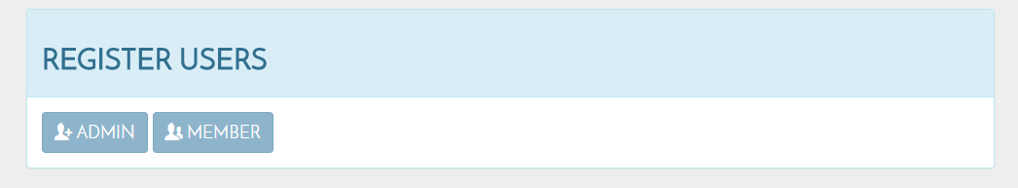

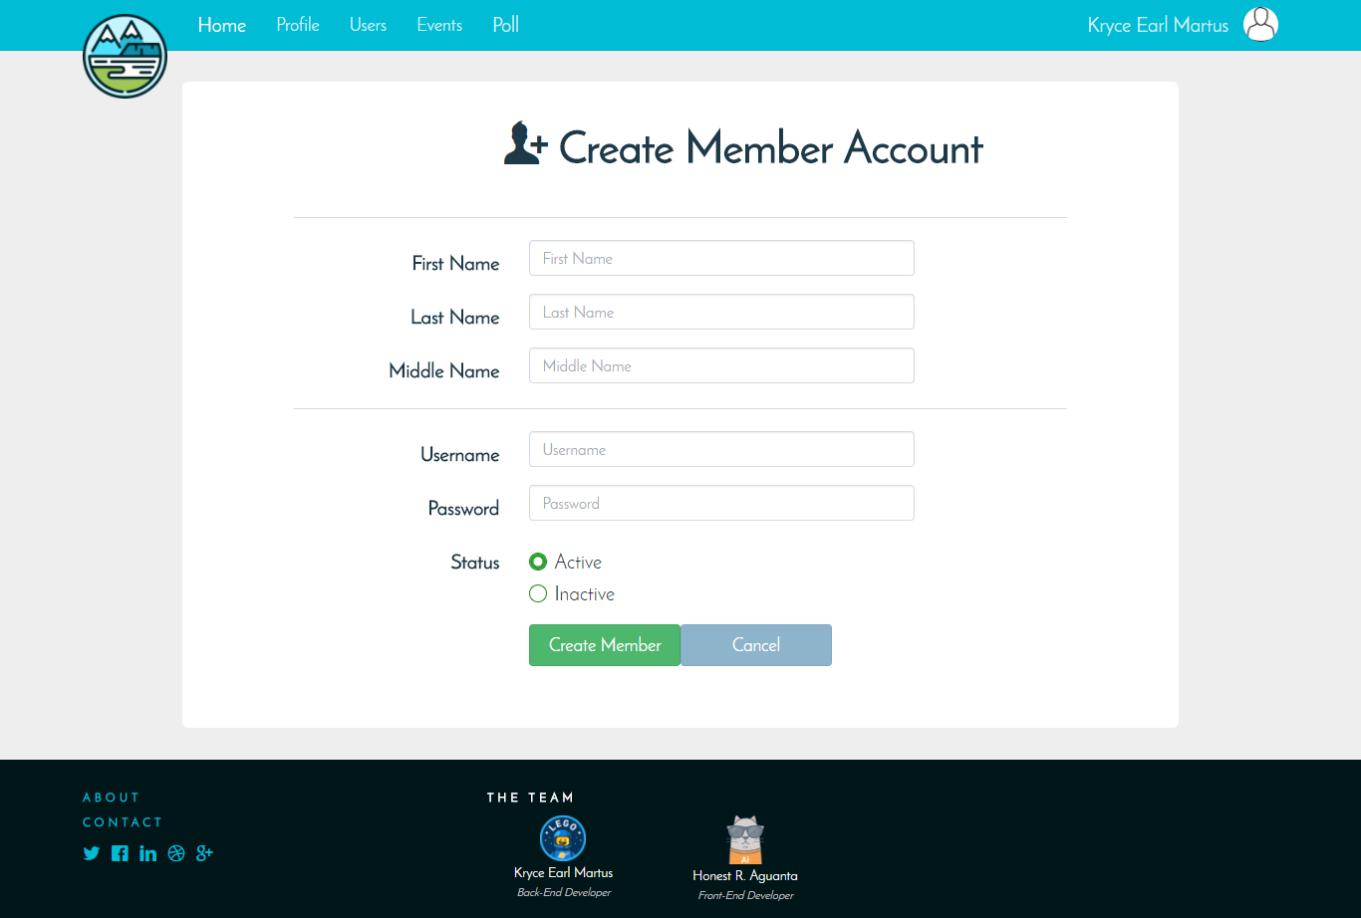

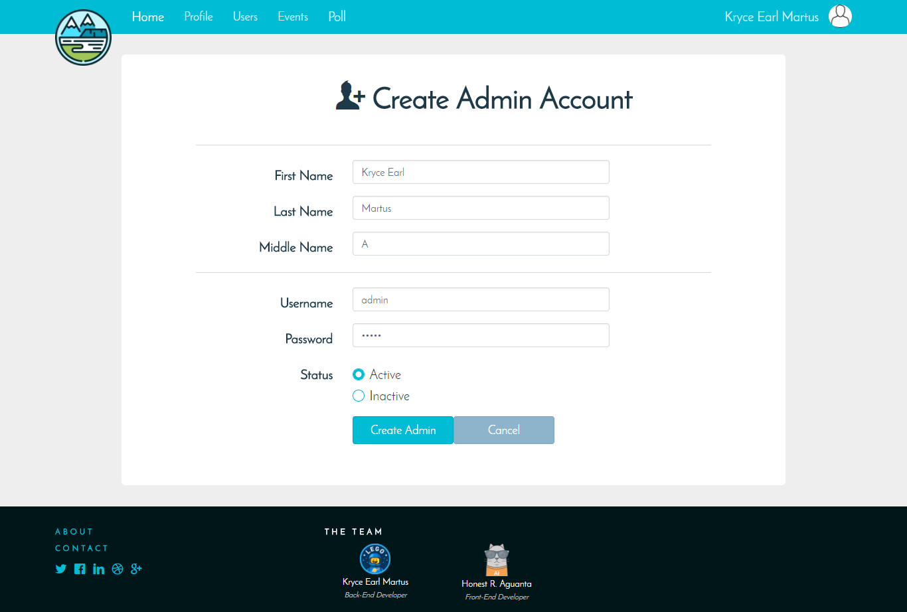

An administrator can edit an User’s details or login details through the Users Page in the data table for the users, by clicking the pen button in the Edit Column.

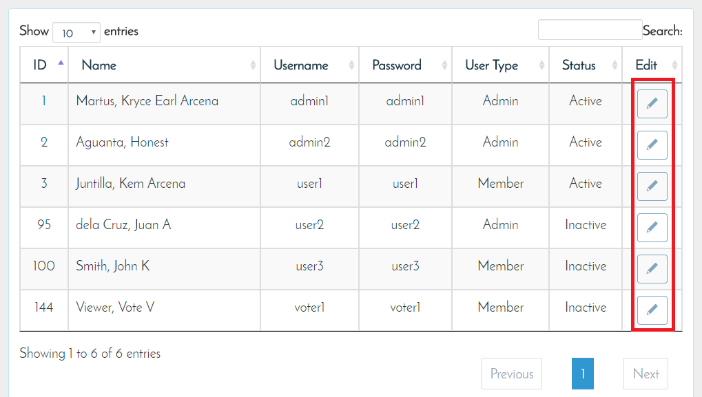

This will lead to the Edit User Page of the user you have selected to edit. After making the changes, select Update. Take note that the Active and Inactive Statuses are important. When an account is Active, the user can vote. And if it’s Inactive, the account’s vote is uncounted to the tallying of votes.

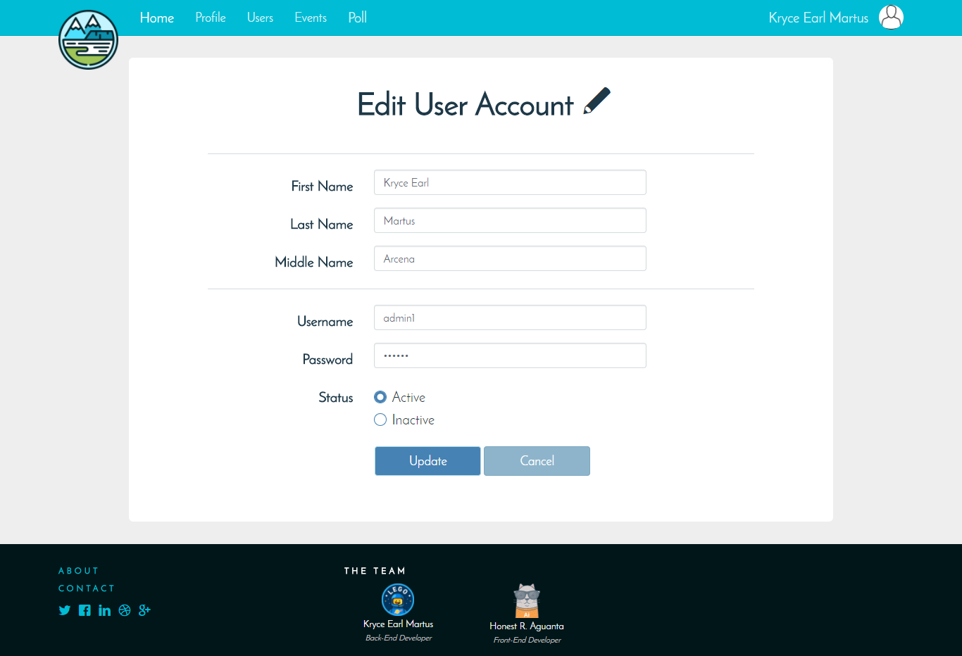

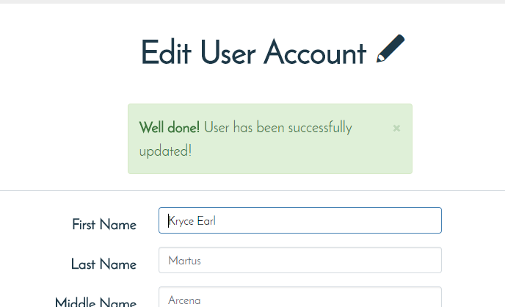

**Event Voting Page:**

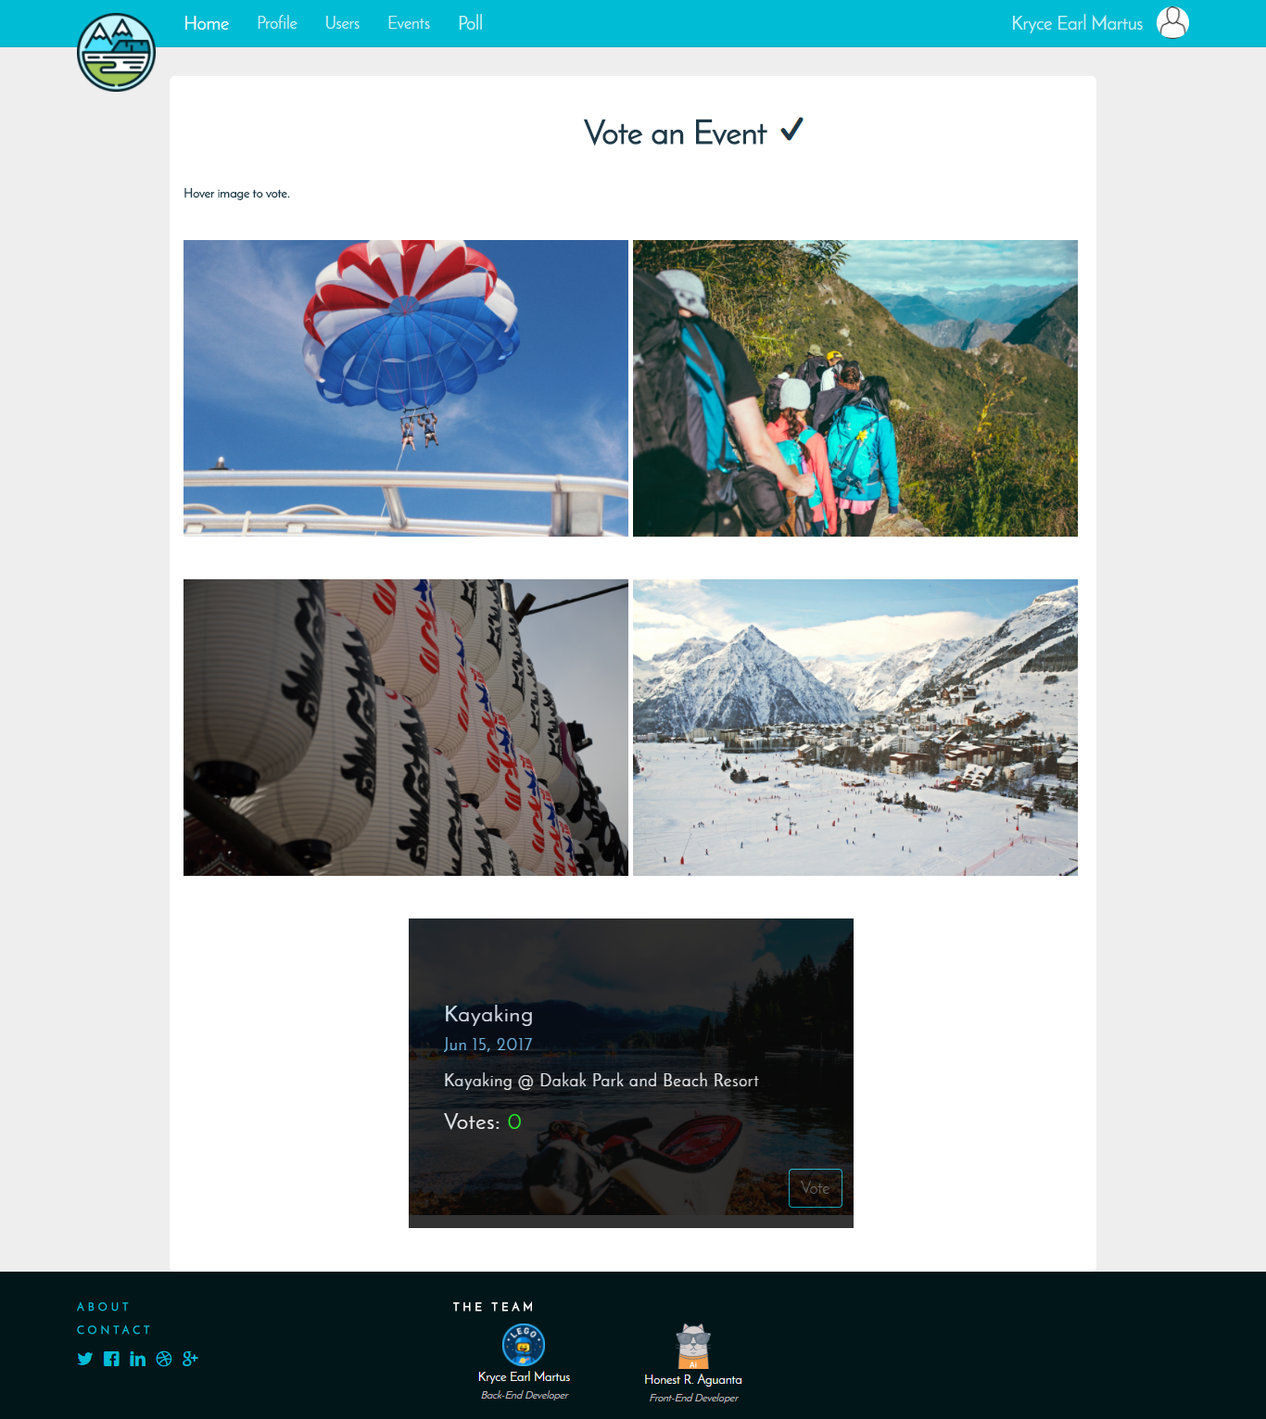

The event voting page will display all events available for a user to vote on. The events are only created through the Events page. To vote for an event, simply hover an image to see the description and decide to vote for it or hover to another event. After deciding click vote and a message will ask for confirmation. Click yes to confirm to vote for the event.

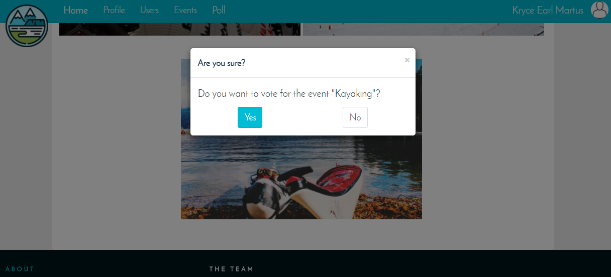

After voting the page will display the events, and emphasizing what the logged-in user has voted. It will also display the current votes each event has.

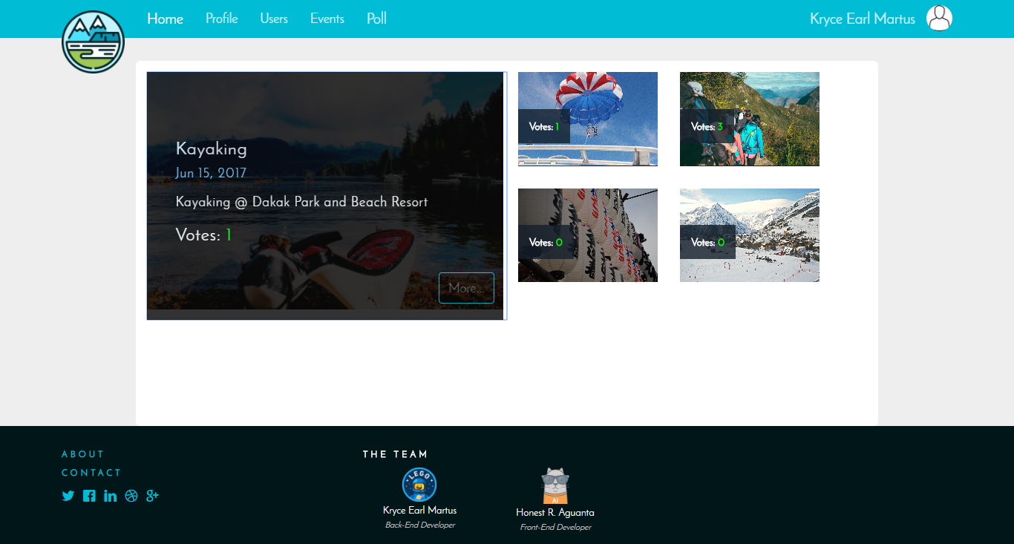

After the last Active user has voted, the event voting will close and the event voting page will prompt the user which event won the voting. By clicking the link in the message, it will redirect the user to the Event Profile of the event. The selected event is also featured in the time-line.

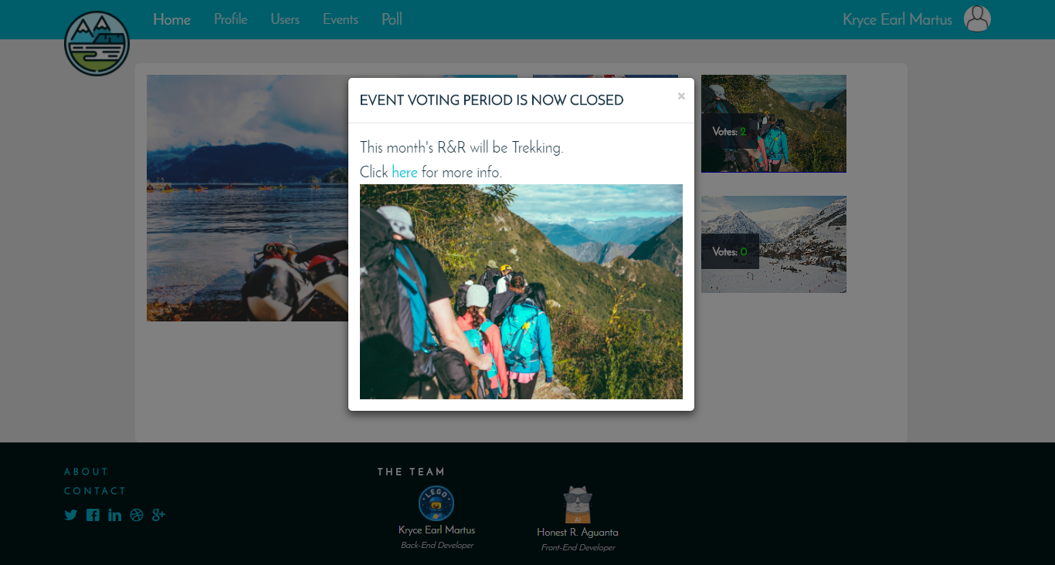

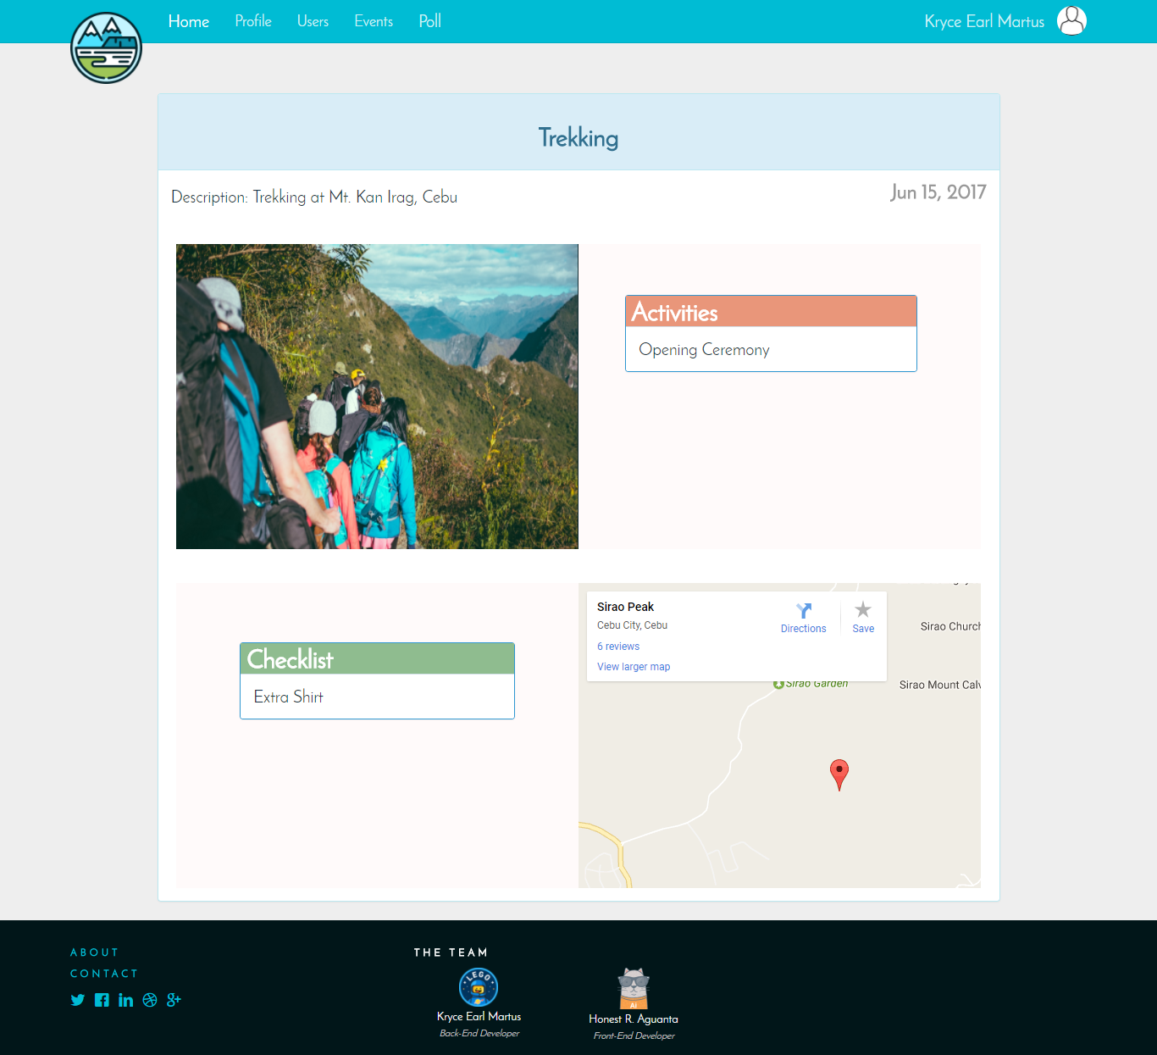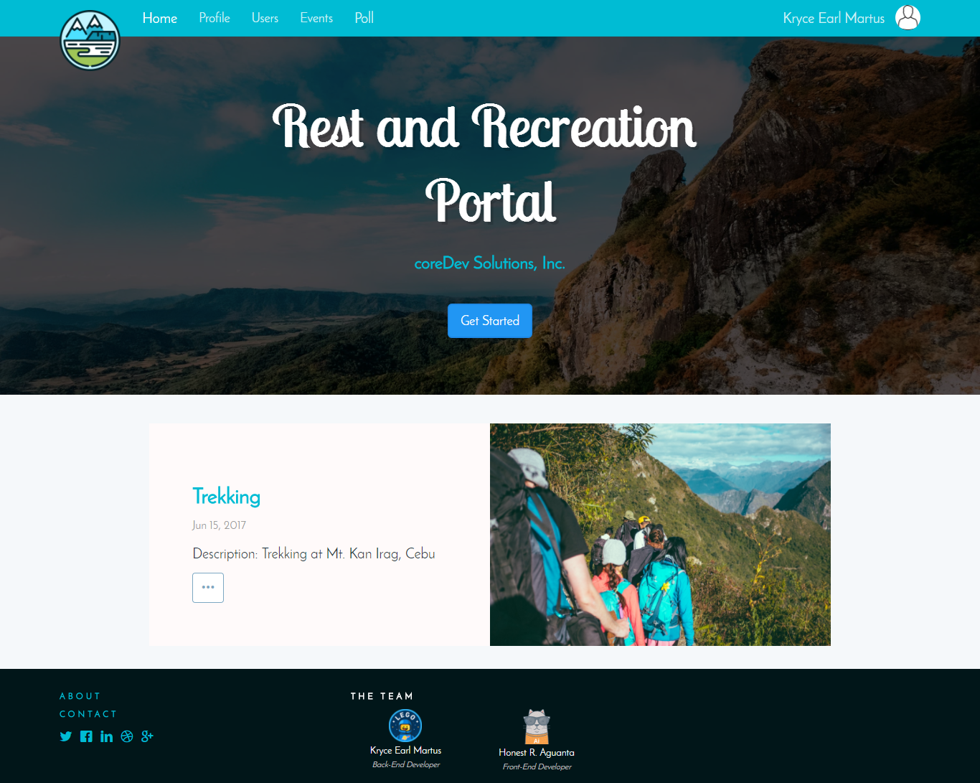

**Error Pages:**

Error404: If an user tries to browse an invalid URL in the navigation bar.

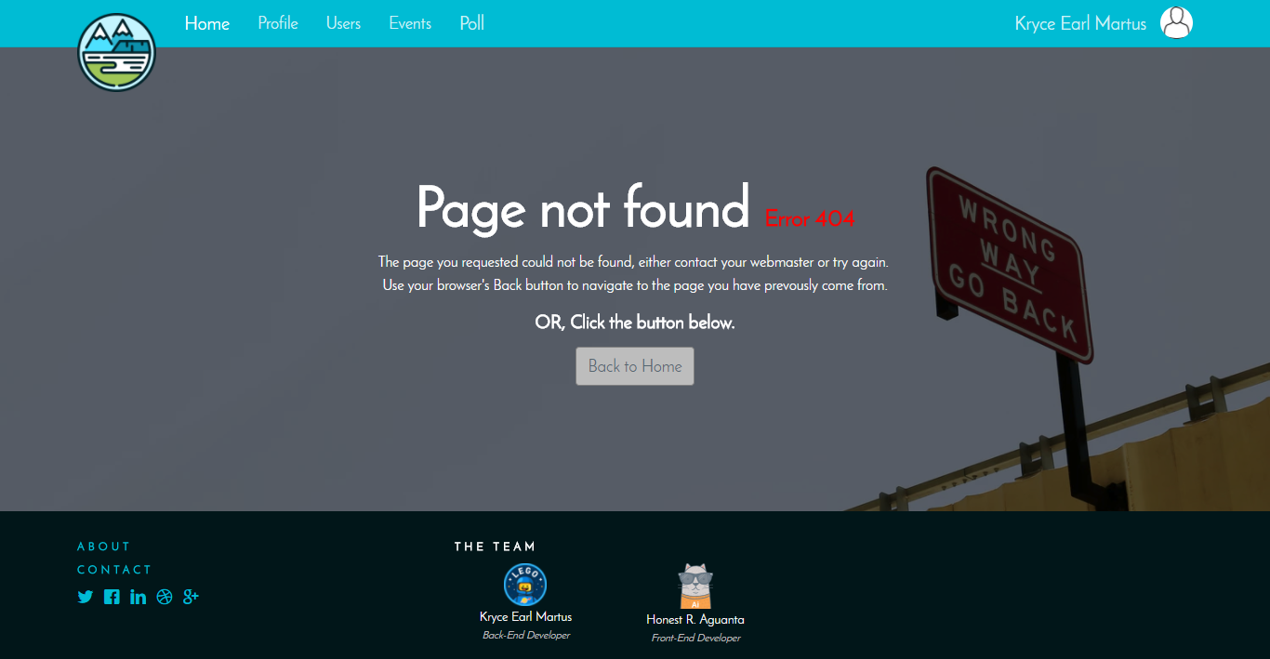

Error403: If a “Member” tries to access pages that only administrator has the right to access.

